**LAB ASSIGNMENT-1**

**INTERNET AND WEB PROGRAMMING**

**1. Design a website to demonstrate the knowledge of students in HTML tags, forms,**

**table, list and HTML frames.**

**i. Create a user registration webpage using HTML Form elements (Input types) for**

**a hackathon event registration. The webpage must contain the following input**

**types to get the details of the students**

**ii. # Input Types:- Text fields, Textarea, checkbox, radio button, submit button,**

**reset button, drop down box, images (if required).**

**iii. # Apply styles, Formatting tags of HTML for good design.**

**iv. # Embed audio or video.**

**v. # Perform form validations with HTML 5 elements**.

PROCEDURE:

TAGS USED:

**<style>**

**<div>,<body>**

**<img>, <input>,<option>,<button>**

CODE:

<!DOCTYPE html>

<html lang="en">

    <meta name="viewport" content="width=device-width, initial-scale=1.0">

    <title>Registration Form</title>

        <h1 style = "border:12px solid white;font-family:Montserrat;font-size:80px;font-style:bold;text-align:center;"> <span style="color:#eceeee">The UltimateHACK.EXE</span></h1>

    <style>

        .body{

            background-image : url(https://media.giphy.com/media/du444G2zanbAnyYRcZ/giphy.gif);

            margin-top:40px;

            background-position:center;

            background-size:cover;

            font-family: Helvetica;

            font-size:auto;font-style:bold;

    }

        .regform{

          width:800px;

            background-color:rgb(37, 28, 28,0.5);

            margin:auto;

            color:#FFFFFF;

            padding:10px 0px 10px 0px;

            text-align:center;

            border-radius:15px 15px 0px 0px ;

    }

        .main{

            background-color:rgb(0,0,0,0.5);

            width:800px;

            margin:auto;}

  form{

      padding:10px;

  }

  #name{

       width:100%;

    height:100px;

    }

  .name{

            margin-left:25px;

   margin-top:30px;

   width: 125px;

            color: white;

            font-size: 18px;

            font-weight: 700;}

.firstname{

                   position: relative;

       left:200px;

       top:-37px;

       line-height: 40px;

       border-radius: 6px;

       padding: 0 22px;

       font-size: 16px;

       }

.lastname{

             position: relative;

       left:417px;

       top:-80px;

       line-height: 40px;

       border-radius: 6px;

       padding: 0 22px;

       font-size: 16px;

       color:#555;

                  }

 .firstlabel{

            position:relative;

            color:#E5E5E5;

      text-transform: capitalize;

   font-size: 14px;

   left:203px;

   top:-45px;

   }

.lastlabel{

            position:relative;

   color:#E5E5E5;

   text-transform:capitalize;

   font-size:14px;

   left:492px;

   top:-76px;

     }

.company{

           position:relative;

     left:200px;

     top:-37px;

     line-height: 40px;

     width:480px;

        border-radius: 6px;

     padding: 0 22px;

     font-size: 16px;

     color: #555;  }

 .email{

        position:relative;

  left:200px;

     top:-37px;

     line-height: 40px;

     width:480px;

        border-radius: 6px;

     padding: 0 22px;

     font-size: 16px;

     color: #555;

    }

   .Code{

         position:relative;

  left:200px;

     top:-37px;

     line-height: 40px;

     width:95px;

        border-radius: 6px;

     padding: 0 22px;

     font-size: 16px;

     color: #555;

  }

 .number{

         position:relative;

  left:200px;

     top:-37px;

     line-height: 40px;

     width:255px;

        border-radius: 6px;

     padding: 0 22px;

     font-size: 16px;

     color: #555;

     }

 .area-code{

            position:relative;

      color:#E5E5E5;

      text-transform:capitalize;

      font-size:16px;

      left:54px;

      top:-4px;

     }

 .phone-number{

              position:relative;

      color:#E5E5E5;

      text-transform:capitalize;

      font-size:16px;

      left:-100px;

      top:-2px;

     }

 .option{

         position:relative;

  left:200px;

     top:-37px;

     line-height: 40px;

     width:532px;

     height:40px;

        border-radius: 6px;

     padding: 0 22px;

     font-size: 16px;

     color: #555;

     outline:none;

     overflow:hidden;

  }

     .option option{

                 font-size:20px;

       }

   #coustomer{

                margin-left:25px;

    color:white;

    font-size:18px;

      }

     .radio{

         display:inline-block;

   padding-right:70px;

   font-size:25px;

   margin-left:25px;

   margin-top:15px;

   color:white;

   }

  .radio input{

              width:20px;

     height:20px;

     border-radius:50%;

     cursor:pointer;

     outline:none;

    }

    button{

        background-color:#3BAF9F;

     display:block;

     margin:20px 0px 0px 20px;

     text-align:center;

     border-radius:12px;

     border:2px solid #366473;

     padding:14px 110px;

     outline:none;

     color:white;

     cursor:pointer;

     transition:0.25px;

    }

   button:hover{

                background-color:#5390F5;

      }

      .navbar {

  background-color: #333;

  overflow: hidden;

  position: fixed;

  bottom: 0;

  width: 100%;

}

.navbar a {

  float: left;

  display: block;

  color: #f2f2f2;

  text-align: center;

  padding: 14px 16px;

  text-decoration: none;

  font-size: 17px;

}

.navbar a:hover {

  background-color: #ddd;

  color: black;

  size: auto;

}

.navbar a.active {

  color: white;

}

    </style>

<head>

    <meta charset="UTF-8">

    <meta name="viewport" content="width=device-width, initial-scale=1.0">

    <title>Document</title>

</head>

<body class="body">

    <div class="regform">

        <h1>

 Registration Form</h1>

</div>

<div class="main">

        <form method="POST">

            <div id="name">

                <h2 class="name">

Name </h2>

<input class="firstname" type="text" name="first_name"><br>

                <label class="firstlabel">first name</label>

                <input class="lastname" type="text" name="last_name"><br>

                <label class="lastlabel">last name</label>

            </div>

            <h2 class="name">

                Registration Number </h2>

                <input class="company" type="text" name="company">

<h2 class="name">

Team Name </h2>

<input class="company" type="text" name="company">

            <h2 class="name">

Email</h2>

<input class="email" type="email" name="email">

            <h2 class="name">

Phone</h2>

<input class="Code" type="text" name="area_code">

            <label class="area-code">Area Code</label>

            <input class="number" type="text" name="phone">

            <label class="phone-number">Phone Number</label>

            <h2 class="name">

Domain</h2>

<select class="option" name="Domain">

                <option disabled="disabled" selected="selected">--Choose option--</option>

                <option>Machine Learning</option>

                <option>Artificial Intelligence</option>

                <option>Deep Learning</option>

            </select>

            <h2 id="coustomer">

Gender</h2>

<label class="radio">

                <input class="radio-one" type="radio" checked="checked" name="rdiobtn">

                <span class="checkmark"></span>

                Female

            </label>

            <label class="radio">

                <input class="radio-two" type="radio" name="rdiobtn">

                <span class="checkmark"></span>

                Male

            </label>

            <button type="submit">Register</button>

        </form>

        <h2 style="text-align: center; font-weight: bolder;color:#FFFFFF">

            After Movie 20-21'</h2>

            <iframe width="560" height="315" src="https://www.youtube.com/embed/33om6HqqIHU" frameborder="0" allow="accelerometer; autoplay; encrypted-media; gyroscope; picture-in-picture" allowfullscreen></iframe>

</div>

</body>

<div class="navbar">

    <a href="#home" class="active">Home</a>

    <a href="#news">News</a>

    <a href="#contact">Contact</a>

  </div>

</html>

**HTML PAGE LOOKS:**



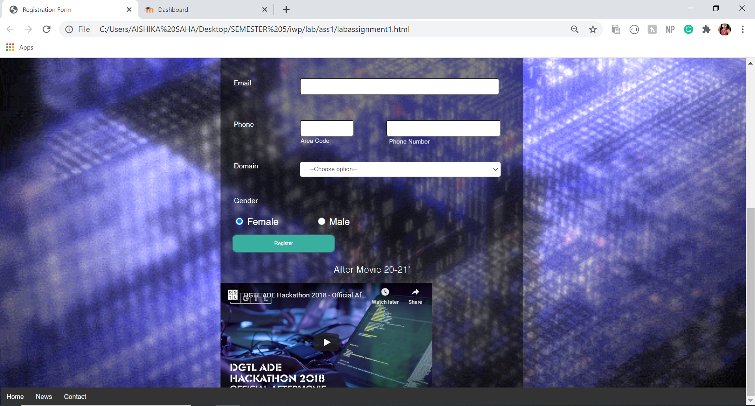

2. Write a program to demonstrate the concept of HTML Image mapping element.

i. Add an image of the cricket playground.

ii. Use image mapping to give the details about the various fielding

positions. (gully, slip etc., - write description about it and your favourite

fielders at that point).

PROCEDURE:

Tags used:

**<head>, <body>, <tag>, <img>,<area>,<div>**

**SCREENSHOT OF THE EDITOR (CODE AT THE BOTTOM OF THE FILE):**

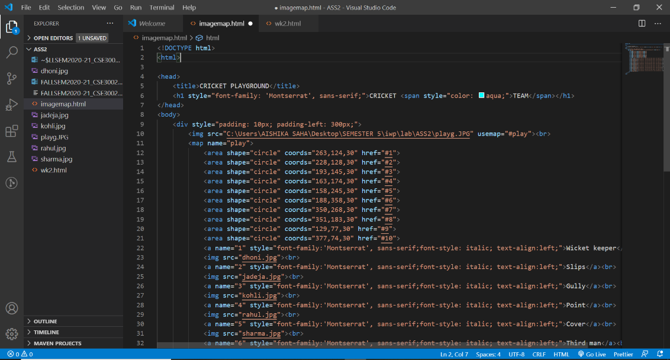

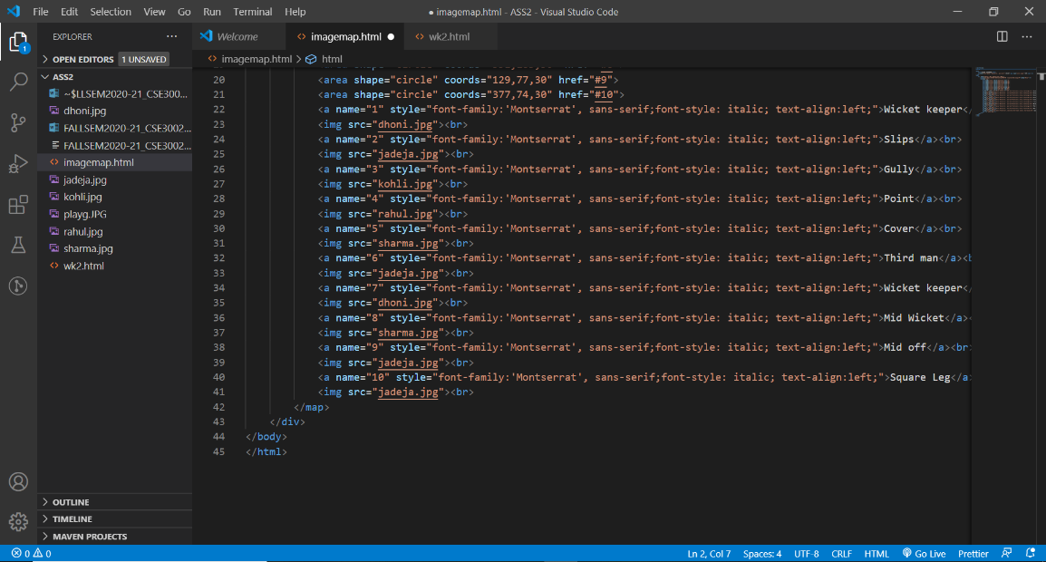

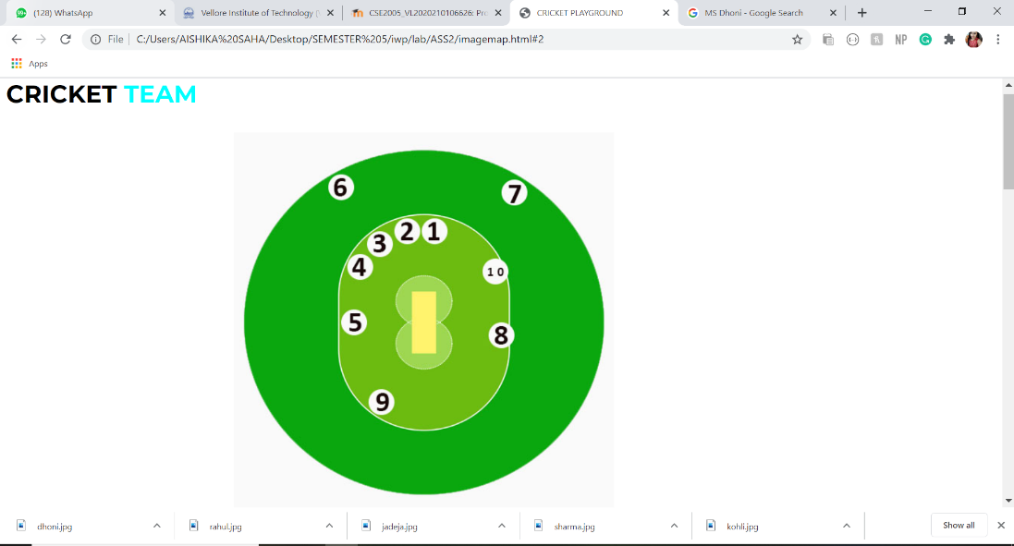**HTML PAGE:**

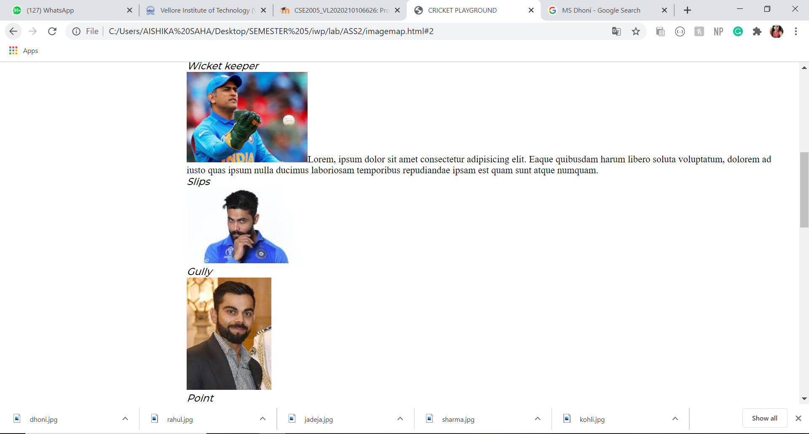

**Code:**

<!DOCTYPE html>

<html>

<head>

    <title>CRICKET PLAYGROUND</title>

    <h1 style="font-family: 'Montserrat', sans-serif;">CRICKET <span style="color: aqua;">TEAM</span></h1>

</head>

<body>

    <div style="padding: 10px; padding-left: 300px;">

        <img src="C:\Users\AISHIKA SAHA\Desktop\SEMESTER 5\iwp\lab\ASS2\playg.JPG" usemap="#play"><br>

        <map name="play">

            <area shape="circle" coords="263,124,30" href="#1">

            <area shape="circle" coords="228,128,30" href="#2">

            <area shape="circle" coords="193,145,30" href="#3">

            <area shape="circle" coords="163,174,30" href="#4">

            <area shape="circle" coords="158,245,30" href="#5">

            <area shape="circle" coords="188,358,30" href="#6">

            <area shape="circle" coords="350,268,30" href="#7">

            <area shape="circle" coords="351,183,30" href="#8">

            <area shape="circle" coords="129,77,30" href="#9">

            <area shape="circle" coords="377,74,30" href="#10">

            <a name="1" style="font-family:'Montserrat', sans-serif;font-style: italic; text-align:left;">Wicket keeper</a><br>

            <img src="dhoni.jpg">Lorem, ipsum dolor sit amet consectetur adipisicing elit. Eaque quibusdam harum libero soluta voluptatum, dolorem ad iusto quas ipsum nulla ducimus laboriosam temporibus repudiandae ipsam est quam sunt atque numquam.<br>

            <a name="2" style="font-family:'Montserrat', sans-serif;font-style: italic; text-align:left;">Slips</a><br>

            <img src="jadeja.jpg"><br>

            <a name="3" style="font-family:'Montserrat', sans-serif;font-style: italic; text-align:left;">Gully</a><br>

            <img src="kohli.jpg"><br>

            <a name="4" style="font-family:'Montserrat', sans-serif;font-style: italic; text-align:left;">Point</a><br>

            <img src="rahul.jpg"><br>

            <a name="5" style="font-family:'Montserrat', sans-serif;font-style: italic; text-align:left;">Cover</a><br>

            <img src="sharma.jpg"><br>

            <a name="6" style="font-family:'Montserrat', sans-serif;font-style: italic; text-align:left;">Third man</a><br>

            <img src="jadeja.jpg"><br>

            <a name="7" style="font-family:'Montserrat', sans-serif;font-style: italic; text-align:left;">Wicket keeper</a><br>

            <img src="dhoni.jpg"><br>

            <a name="8" style="font-family:'Montserrat', sans-serif;font-style: italic; text-align:left;">Mid Wicket</a><br>

            <img src="sharma.jpg"><br>

            <a name="9" style="font-family:'Montserrat', sans-serif;font-style: italic; text-align:left;">Mid off</a><br>

            <img src="jadeja.jpg"><br>

            <a name="10" style="font-family:'Montserrat', sans-serif;font-style: italic; text-align:left;">Square Leg</a><br>

            <img src="jadeja.jpg"><br>

        </map>

    </div>

</body>

</html>